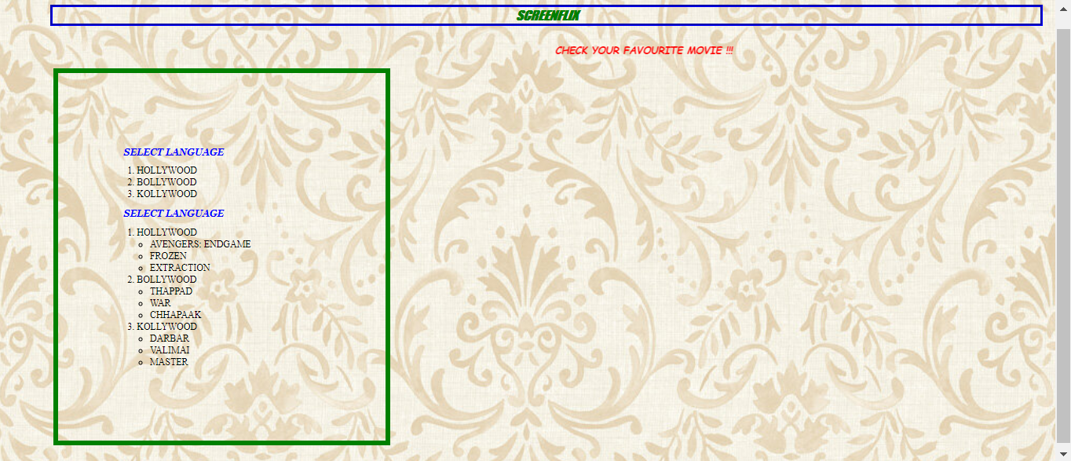

CSS BOX MODEL

SCREENFLIX – H1 TAG WITH BOLD TAG IS USED WITH BORDER STYLE IS GROOVE AND BORDER COOR IS GREEN

🡪use font attributes

CHECK YOUR FAV MOVIE – MARQUEE AND H2 TAG WITH CLASS ATTRIBUTE IS USED FOR CSS COLOR

🡪use font attributes

SELECT LANGUAGE – H3 TAG WITH CLASS ATTRIBUTE IS USED FOR CSS COLOR

🡪use font attributes

HOVERING ON THE LIST ITEM USED WITH CSS COLORS

TO INCLUDE BOX MODEL

Use these:

Background-color:none,width,border,padding and margin elements

NOTE: if you want to set padding properly then use css padding options